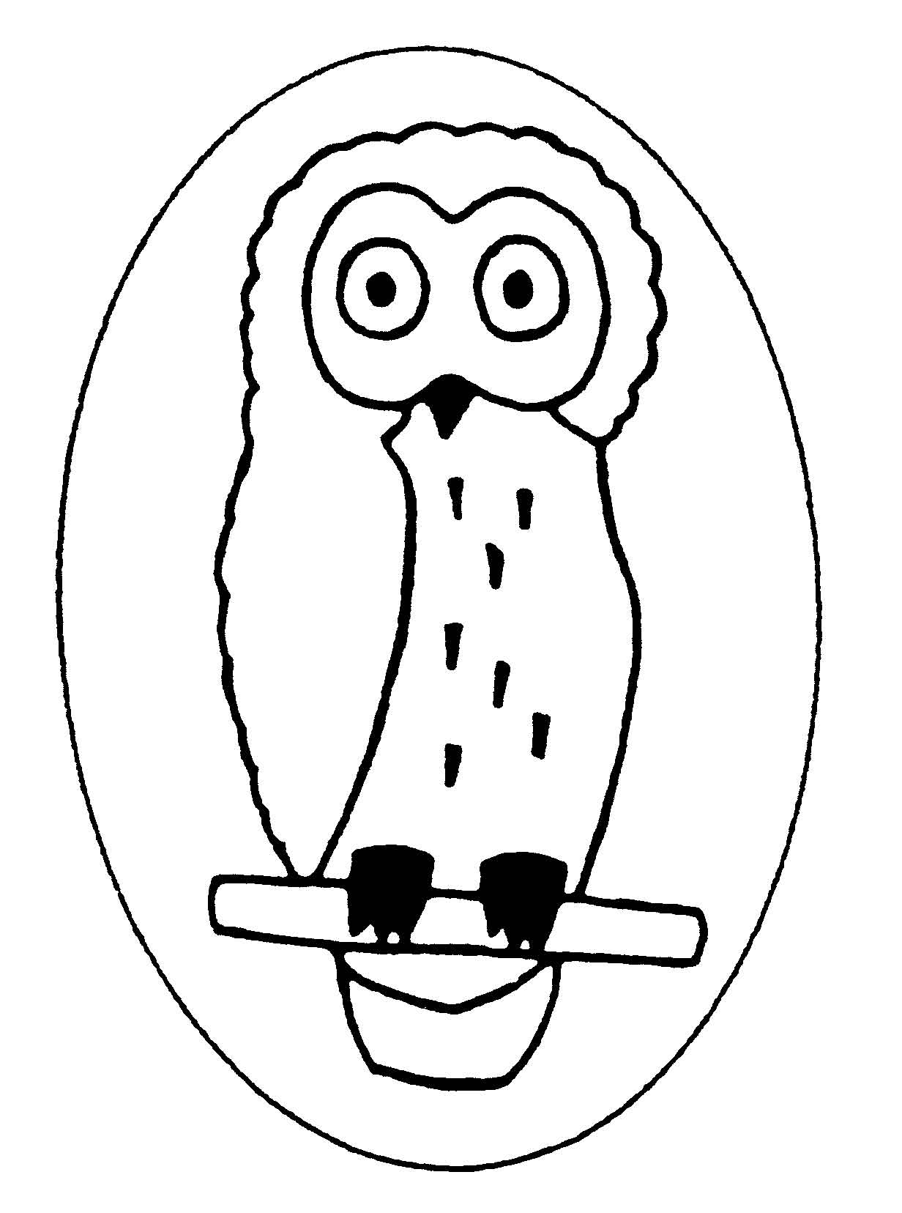
Dry Sandford County Primary School
Lashford Lane, Dry Sandford, Abingdon, Oxon, OX13 6EE
Tel/Fax: 01865 730 432
head.2565@dry-sandford.oxon.sch
office.2565@dry-sandford.oxon.sch.uk
www.dry-sandford.oxon.sch.uk

Headteacher: Mrs Katie Friday BEd (Hons), QTS

Snowy Owls Curriculum Letter

Welcome to the Spring Term
We have had a great start to 2024 and have been busy learning and find out about our new topic ‘’Over the Misty Mountains”, which is all about mountains, volcanoes and earthquakes.

We will be covering the following areas in the curriculum in the spring term:
Maths | Multiplication and division, length area and perimeter, fractions, decimals and mass and capacity
English | Story writing – opening, build up and climax, newspaper reports and biographies Spelling, grammar and handwriting
Science | The digestive system (including teeth) and the skeleton, muscles and nutrition
RE | Judaism and Christianity
PSHE | Dreams and goals and healthy me
Humanities | Geography with a focus on the earth, plate tectonics, volcanoes, earthquakes, mountains, the water cycle and historical events and explorers
Art and DT | Landscape artists, painting, drawing, sculpting, patterns and print making
PE | Gymnastics and dance
Music | Singing, playing the recorded, listening to music and creating music
Computing | Coding and text and multimedia

PE this term will be on Thursday, but we may have an extra session at some point during the week so please can the children keep their kits in school every day. Please ensure your child has a PE top, black bottoms and trainers. Jewellery is not allowed and earrings should be removed or covered with a plaster for safety during PE. It is also important that the children have indoor and outdoor shoes each day.

Each week the children have reading, maths, spelling homework. The spellings have been sent out for at the beginning of the half term and they are tested on Mondays. The maths homework is all online and is set on Friday afternoons. Please see the table below for a suggestion on how to complete:
 | Reading | Doodle Maths (online) | Spelling
Monday | 10 mins | 15 mins | 10 mins
Tuesday | 10 mins | 15 mins
Wednesday | 10 mins |  | 10 mins
Thursday | 10 mins | 15 mins
Friday | 10 mins |  | 10 mins

Regular reading each day at home will really help support your child with all areas of learning. There should be 5 brief summaries of reading per week and the children can record their own comments to say what has happened in the section of story they have read and an adult should sign once a week. Please check your child’s book bag daily for letters and other pieces of information.

Thank you very much for all of your support,
Miss N Chandler

